Adjacent-Figure Composition

Definition
# Source: AI Source: Provided by: [Data Path: Persons Table -> ID Column: 1, Name_En Column: Motasem Essam] -> From: [ChatGPT] on [7/25/2026]
Adjacent-Figure Composition is a type of geometric figure composition in which two or more geometric figures are positioned next to one another, typically sharing a boundary segment, edge, or vertex, without their interiors overlapping.
The figures may form a larger composite shape, or they may remain distinct shapes connected at their boundaries.

Simple Definition
# Source: AI Source: Provided by: [Data Path: Persons Table -> ID Column: 1, Name_En Column: Motasem Essam] -> From: [ChatGPT] on [7/25/2026]
Adjacent-figure composition means placing geometric shapes next to each other so that they touch or share a boundary without overlapping interiors.
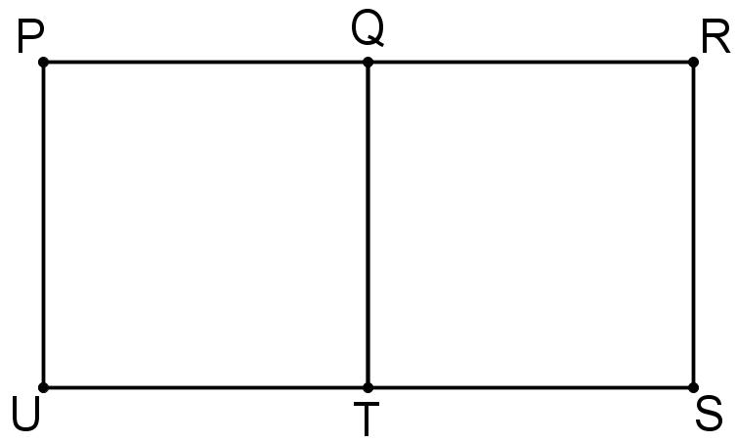
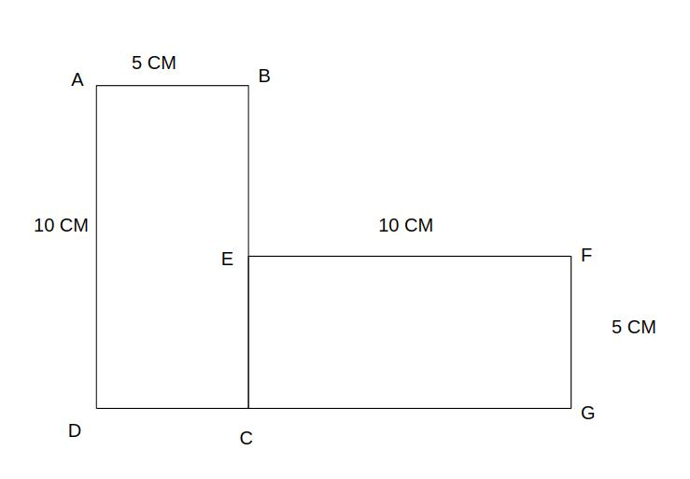
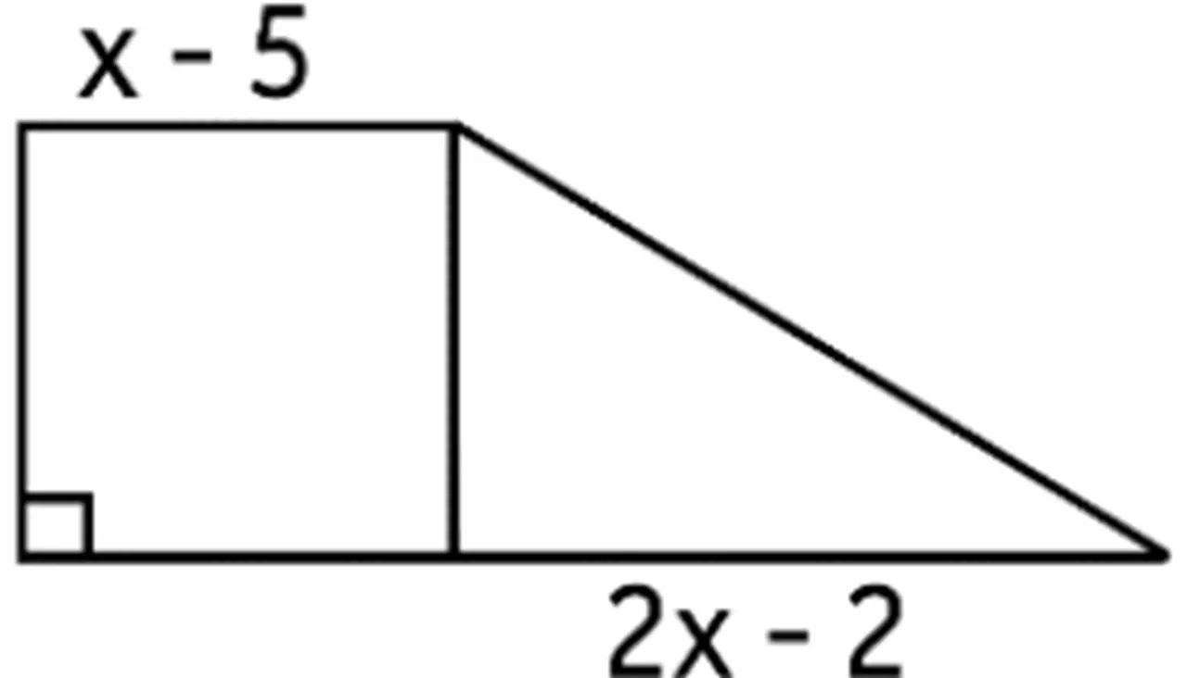

Main Classification
# Source: AI Source: Provided by: [Data Path: Persons Table -> ID Column: 1, Name_En Column: Motasem Essam] -> From: [ChatGPT] on [7/25/2026]
The following is a practical classification based on how adjacent figures meet. These categories are descriptive rather than a universally standardized taxonomy, and some can overlap.

1. Full-Edge Adjacent-Figure Composition
# Source: AI Source: Provided by: [Data Path: Persons Table -> ID Column: 1, Name_En Column: Motasem Essam] -> From: [ChatGPT] on [7/25/2026]
Two figures meet along an entire side or edge of each figure.
Example: Two equal squares sharing one complete side to form a rectangle.
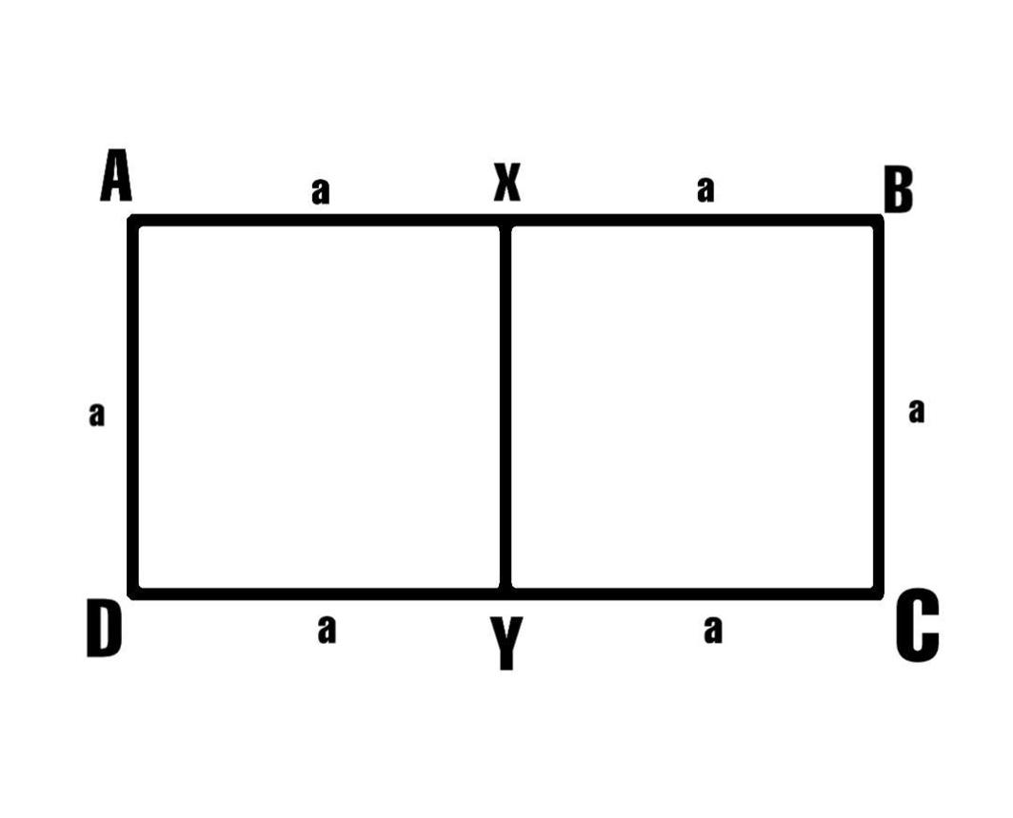
Detailed Explanation and Examples
Definition: Two figures share an entire corresponding side or edge.
Example: Two squares each have side length $4$units and share one full side.
Their combined outline forms a rectangle with dimensions $8×4$.
$$A_{\text{total}}=4^{2}+4^{2}=32$$
square units.
The outer perimeter is
$$P=2\left(8+4\right)=24$$
units.
The shared side is internal and is not counted in the outer perimeter.

2. Partial-Edge Adjacent-Figure Composition
# Source: AI Source: Provided by: [Data Path: Persons Table -> ID Column: 1, Name_En Column: Motasem Essam] -> From: [ChatGPT] on [7/25/2026]
Two figures share only part of a boundary.
Example: A small rectangle touches part of the longer side of a larger rectangle.
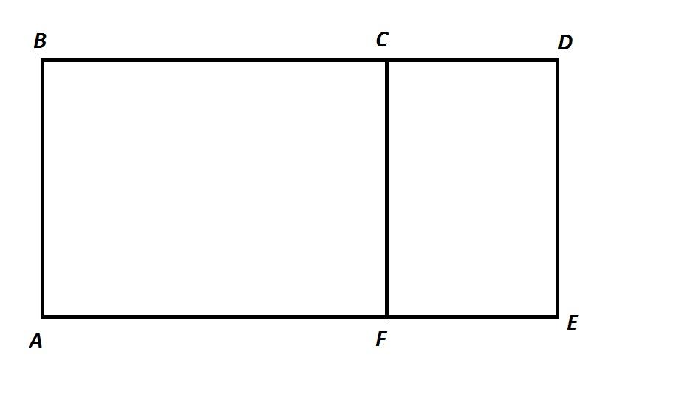
Detailed Explanation and Examples
Definition: Two figures share only a portion of one or both of their boundaries.
Example: A small rectangle is positioned against part of the longer side of a larger rectangle, with their interiors on opposite sides of the shared segment.
If the figures have areas $A_{1}$and $A_{2}$, and their interiors do not overlap,
$$A_{\text{total}}=A_{1}+A_{2}.$$
The shared boundary's length must be considered when calculating the outer perimeter.
For polygons sharing a boundary segment of length $s$, with no other shared boundary portions,
$$P_{\text{total}}=P_{1}+P_{2}-2s.$$

3. Point-Adjacent Figure Composition
# Source: AI Source: Provided by: [Data Path: Persons Table -> ID Column: 1, Name_En Column: Motasem Essam] -> From: [ChatGPT] on [7/25/2026]
Two figures touch at exactly one point, without sharing a boundary segment.
Example: Two triangles meeting at a single vertex.

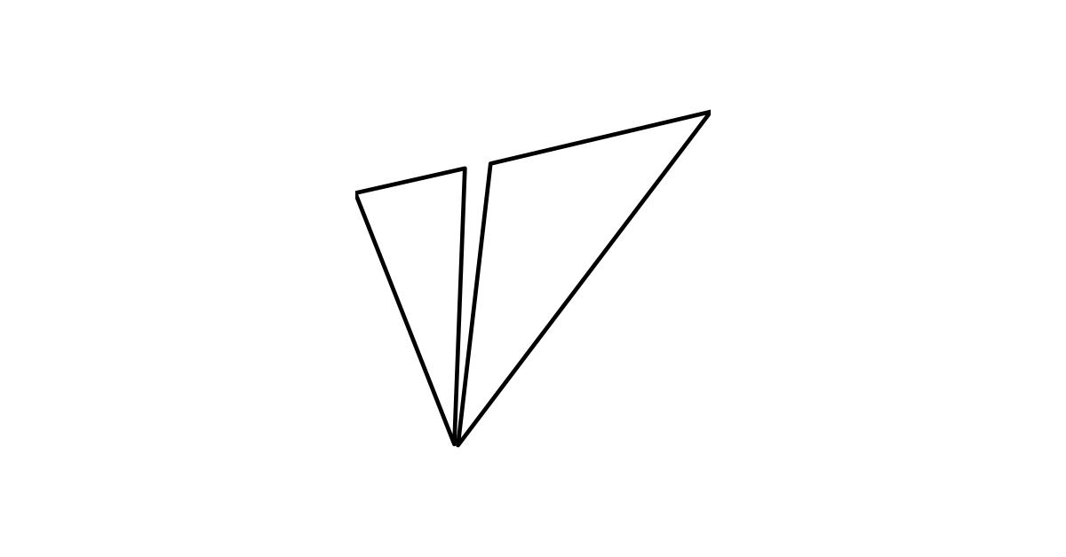
Detailed Explanation and Examples
Definition: Two figures meet at one point but do not share an edge.
Example: Two triangles meet at vertex $O$, with the rest of each triangle lying in a separate region.
Their total area is the sum of their individual areas:
$$A_{\text{total}}=A_{1}+A_{2}.$$
The shared point contributes no area.
Important: A point-connected arrangement does not necessarily form a single simple polygon. The resulting configuration depends on the figures' positions.

4. Edge-Adjacent Figure Composition
# Source: AI Source: Provided by: [Data Path: Persons Table -> ID Column: 1, Name_En Column: Motasem Essam] -> From: [ChatGPT] on [7/25/2026]
Two figures share a common segment or edge, while their interiors remain on opposite sides of the shared boundary.
Example: A triangle and a rectangle sharing a side.
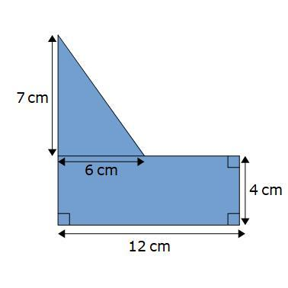
Detailed Explanation and Examples
Definition: Two figures share a boundary segment, and their interiors lie on opposite sides of that segment.
Example: A triangle and a rectangle share a side of length $b=6$units. Suppose the rectangle has height $h_{1}=4$and the triangle has perpendicular height $h_{2}=3$, measured from the shared side.
The combined area is
$$A_{\text{total}}=bh_{1}+\frac{1}{2}bh_{2}.$$
Substituting,
$$A_{\text{total}}=6\left(4\right)+\frac{1}{2}\left(6\right)\left(3\right)$$
$$\boxed{A_{\text{total}}=33}$$
square units.

5. Tangentially Adjacent Figure Composition
# Source: AI Source: Provided by: [Data Path: Persons Table -> ID Column: 1, Name_En Column: Motasem Essam] -> From: [ChatGPT] on [7/25/2026]
Two figures touch at a single point through tangency.
Example: A circle touching a straight line segment at exactly one point, with the segment lying outside the circle except at contact.
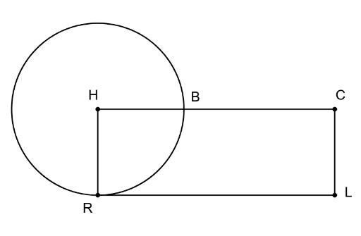
Detailed Explanation and Examples
Definition: Two figures touch at a single point because their boundaries are tangent at that point.
Example: A circle of radius $3$units touches a straight line at point $T$.
The radius drawn to the point of tangency is perpendicular to the tangent line:
$$OT⊥l.$$
This relationship is useful when constructing or analyzing figures that touch without crossing.
Terminology note: A circle tangent to a line is a tangency configuration; whether it is called an adjacent-figure composition depends on the classification being used.

6. Mixed-Shape Adjacent-Figure Composition
# Source: AI Source: Provided by: [Data Path: Persons Table -> ID Column: 1, Name_En Column: Motasem Essam] -> From: [ChatGPT] on [7/25/2026]
Different geometric shape types are placed next to each other and share a boundary.
Example: A rectangle joined to a semicircle along its diameter.
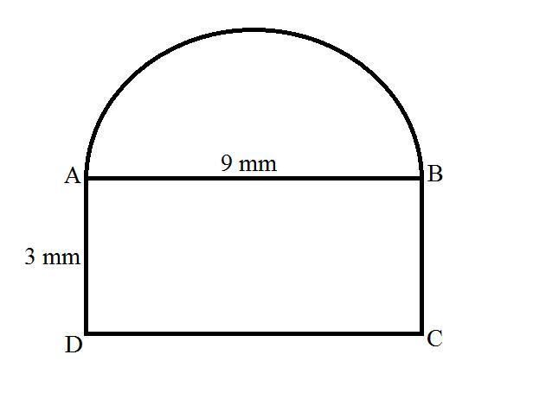
Detailed Explanation and Examples
Definition: Two different shape types share a boundary without their interiors overlapping.
Example: A rectangle of length $L=8$units and width $2r=4$units shares a side with a semicircle of radius $r=2$units.
If the semicircle is attached along a matching diameter, the combined area is
$$A_{\text{total}}=2rL+\frac{1}{2}πr^{2}.$$
Thus,
$$A_{\text{total}}=2\left(2\right)\left(8\right)+\frac{1}{2}π{\left(2\right)}^{2}$$
$$\boxed{A_{\text{total}}=32+2π}$$
square units.

7. Multiple-Figure Adjacent Composition
# Source: AI Source: Provided by: [Data Path: Persons Table -> ID Column: 1, Name_En Column: Motasem Essam] -> From: [ChatGPT] on [7/25/2026]
Three or more figures are arranged side by side, with neighboring figures sharing boundaries or contact points.
Example: Three rectangles arranged to form an L-shaped region.
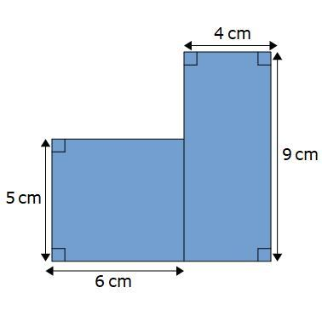
Detailed Explanation and Examples
Definition: Three or more figures are arranged so that neighboring components share boundaries or contact points.
Example: Three rectangles form an L-shaped arrangement. If their interiors do not overlap and their areas are $A_{1},A_{2},A_{3}$, then
$$\boxed{A_{\text{total}}=A_{1}+A_{2}+A_{3}}.$$
The final outline may be a concave polygon, depending on the arrangement.

Important Mathematical Rules

1. Area
# Source: AI Source: Provided by: [Data Path: Persons Table -> ID Column: 1, Name_En Column: Motasem Essam] -> From: [ChatGPT] on [7/25/2026]
For adjacent figures whose interiors do not overlap,
$$\boxed{A_{\text{total}}=\sum_{i=1}^{n}{A_{i}}}$$
Boundary contact does not change the total area because a point or line segment has zero area in the plane.

2. Perimeter
# Source: AI Source: Provided by: [Data Path: Persons Table -> ID Column: 1, Name_En Column: Motasem Essam] -> From: [ChatGPT] on [7/25/2026]
For two polygonal figures sharing a boundary segment of length $s$, and with no other shared boundary portions,
$$\boxed{P_{\text{total}}=P_{1}+P_{2}-2s}.$$
This removes the internal shared edge from both individual perimeters.

3. Adjacency vs. Overlap
# Source: AI Source: Provided by: [Data Path: Persons Table -> ID Column: 1, Name_En Column: Motasem Essam] -> From: [ChatGPT] on [7/25/2026]
- Adjacent figures: Their interiors do not overlap, although their boundaries may touch.
- Overlapping figures: Their interiors share a region of positive area.
- Disjoint figures: They have no points in common.
In some contexts, adjacency specifically means sharing a boundary segment; in others, point contact is also included.

Adjacent-Figure Composition vs. Related Concepts
# Source: AI Source: Provided by: [Data Path: Persons Table -> ID Column: 1, Name_En Column: Motasem Essam] -> From: [ChatGPT] on [7/25/2026]
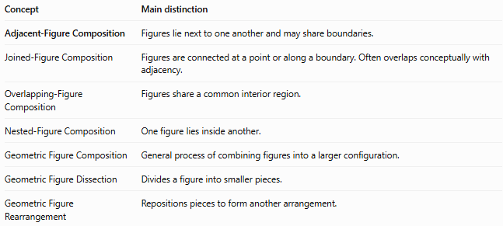
Concept | Main distinction
Adjacent-Figure Composition | Figures lie next to one another and may share boundaries.
Joined-Figure Composition | Figures are connected at a point or along a boundary. Often overlaps conceptually with adjacency.
Overlapping-Figure Composition | Figures share a common interior region.
Nested-Figure Composition | One figure lies inside another.
Geometric Figure Composition | General process of combining figures into a larger configuration.
Geometric Figure Dissection | Divides a figure into smaller pieces.
Geometric Figure Rearrangement | Repositions pieces to form another arrangement.

Classification Summary
# Source: AI Source: Provided by: [Data Path: Persons Table -> ID Column: 1, Name_En Column: Motasem Essam] -> From: [ChatGPT] on [7/25/2026]
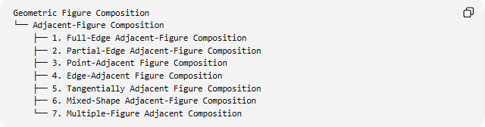
Geometric Figure Composition
└── Adjacent-Figure Composition
├── 1. Full-Edge Adjacent-Figure Composition
├── 2. Partial-Edge Adjacent-Figure Composition
├── 3. Point-Adjacent Figure Composition
├── 4. Edge-Adjacent Figure Composition
├── 5. Tangentially Adjacent Figure Composition
├── 6. Mixed-Shape Adjacent-Figure Composition
└── 7. Multiple-Figure Adjacent Composition
These categories are practical and descriptive, not mutually exclusive. For example, a rectangle joined to a semicircle can be both edge-adjacent and mixed-shape composition.

Key Points
# Source: AI Source: Provided by: [Data Path: Persons Table -> ID Column: 1, Name_En Column: Motasem Essam] -> From: [ChatGPT] on [7/25/2026]
- Adjacent figures are positioned next to each other, generally without overlapping interiors.
- They may share a point, part of a boundary, or a complete edge.
- The total area is the sum of the component areas when their interiors are disjoint.
- Shared internal boundaries must be excluded from the outer perimeter.
- Adjacency and joining are closely related terms, and their exact definitions depend on context.

Conclusion
# Source: AI Source: Provided by: [Data Path: Persons Table -> ID Column: 1, Name_En Column: Motasem Essam] -> From: [ChatGPT] on [7/25/2026]
Adjacent-Figure Composition describes the arrangement of geometric figures next to one another, often sharing a boundary while keeping their interiors separate. It is useful for analyzing composite shapes, calculating areas and perimeters, and studying how smaller geometric figures form larger configurations.

